**SWITCH-ADAPTED BUZZER:**

**Instructions courtesy of Carolinas Neuromuscular/ALS-MDA Center**

**Edwin D. Holt Communication Laboratory**

**Amy Wright, SLP (704) 355-0867** [amy.wright@atriumhealth.org](mailto:amy.wright@atriumhealth.org)

**Equipment/supplies needed*:**

* Soldering iron & Rosin-Core solder
* Power drill
* Wire cutter/stripper
* Project enclosure (small-medium sized)

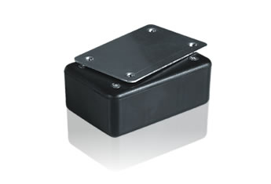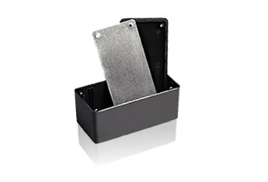

* 12V DC Piezo buzzer or siren (or similar)

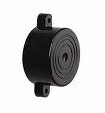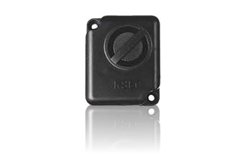

* 9V Battery Snap Connecters

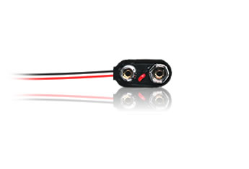

* 1/8” Mono Phone Jack

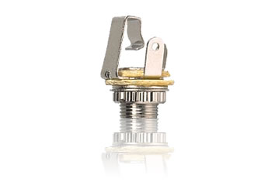

* electrical tape (optional)
* double sided tape or Velcro

*ours were purchased at Radio Shack’s website

**Instructions:**

1. drill 2 holes into project enclosure plastic lid - approximately 1” apart with ¼” drill bit (one for switch/phone jack and one for piezo wires)
2. remove excess plastic from drill site/hole and mount phone jack with solder tabs on inside of enclosure
3. strip ends of all wires with wire stripper
4. attach piezo to outside of box w/double-sided tape and run wires through 2nd hole
5. solder end of battery connector red wire to one side of jack (loop wire through solder tab first to secure)
6. solder end of piezo red wire to other side of jack (loop wire through solder tab first to secure)
7. solder stripped ends of black wires together and secure with electrical tape if desired
8. connect 9V battery. If desired, secure inside the box with Velcro to keep it from sliding around
9. replace lid of box/enclosure and secure with screws provided (OK to discard aluminum lid)
10. plug switch into switch jack and activate to see if it works!

