New Xfinity Aim Anywhere Remotes: IF your remote does not pair with the Tobii-Dynavox

I- Series device or only pairs with the volume controls (volume up/down and mute)

1. First, make sure you have contacted Comcast/Xfinity to make sure you have an IR only remote

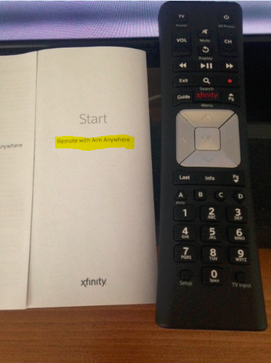

Aim Anywhere remotes even though they are IR based can aim anywhere in the room and still control the TV (you can aim it towards the window or the hallway and it will control the TV)

1. Then, check your remote’s instruction booklet for directions on how to turn off the aim anywhere feature.

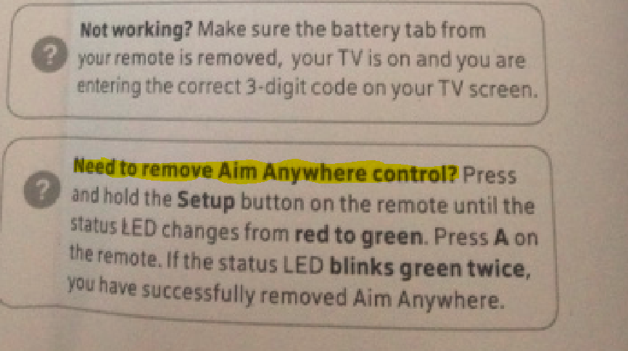

1. Try pairing the remote with the I-Series device.