iPod Touch/iPhone as a Communication Device
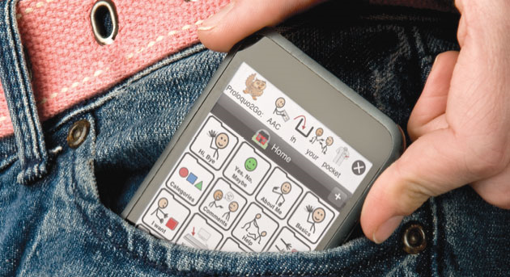

For those PALS (Patients with ALS) who have good hand function, but just have trouble speaking, this may be a solution for you.

If you already own an iPod Touch or iPhone, there are a host of applications that you can purchase to have your device speak out loud things that you type or select on a screen:
Proloquo2go | Fully featured communication software with over 7000 items. Good quality voices. www.proloquo2go.com | $189.99 on iTunes
Talk Assist | Speaks anything typed into the application. Phrases can be saved, and it also keeps a history of typed phrases. | Free on iTunes
iSpeech – Text to Speech | Speaks anything typed into the application. | Free on iTunes
Speak it! Text to Speech | Turns anything a user types into speech. Good voice synthesizer with very clear speech. | $1.99 on iTunes
Talk to Me – Text to Speech | Speaks words as they are typed, and will speak whole phrases. | $1.99 on iTunes
Locabulary | Speaks preprogrammed word/phrases. | Free on iTunes
Small Talk to Aphasia | Designed for people with aphasia, Small Talk provides a vocabulary of pictures and videos that talk in a natural human voice. | Free on iTunes

If you do not have an iPod Touch or iPhone, you may be interested in this option. You should go to a store that sells iPod Touches or iPhones to see how you like the touch screen before you purchase this device.

Other accessories that you may find helpful:
Ewest Super Mini Stereo Speaker | 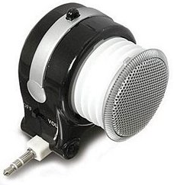
iMainGo 2 Handheld Speaker Case | 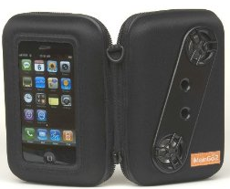
If you have difficulty touching the screen, there is a stylus that you can purchase to help make selecting items easier called the Pogo Stylus. | 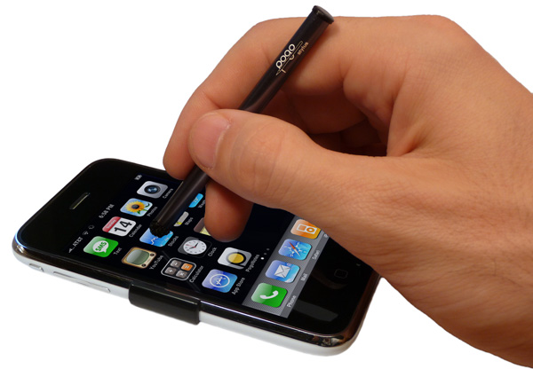
There is a company that sells all of these components bundled together to use the Proloquo2Go sotware: http://www.orin.com/access/Proloquo2Go/ | 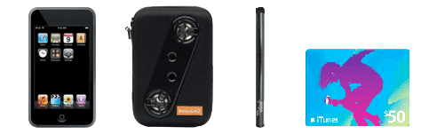

Alternatively, you could purchase all of the pieces separately on your own. FYI – the apple store has refurbished iPod Touches for a discount price. http://store.apple.com

These devices do not have the same capabilities as a high tech communication device, but for some patients this can be a good solution.

